**Web Server Configuration in CentOS:**

Mount the drive and clears all cached files from enabled repository in the YUM cache:

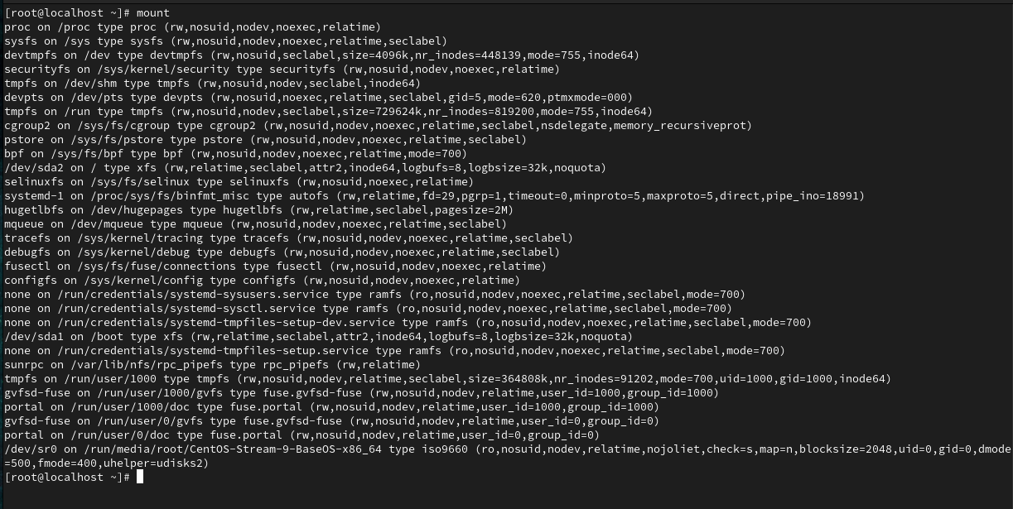



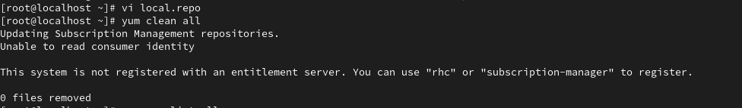

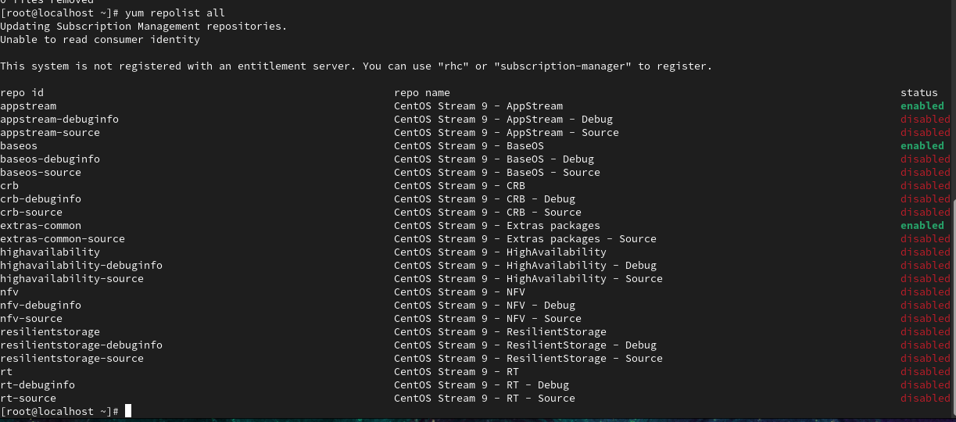

**Start , Enable and check Status of the Web Server:**

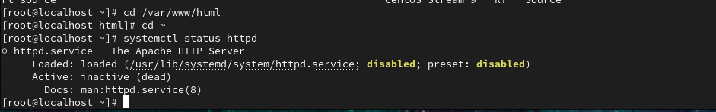

**Configuring the Firewall:**

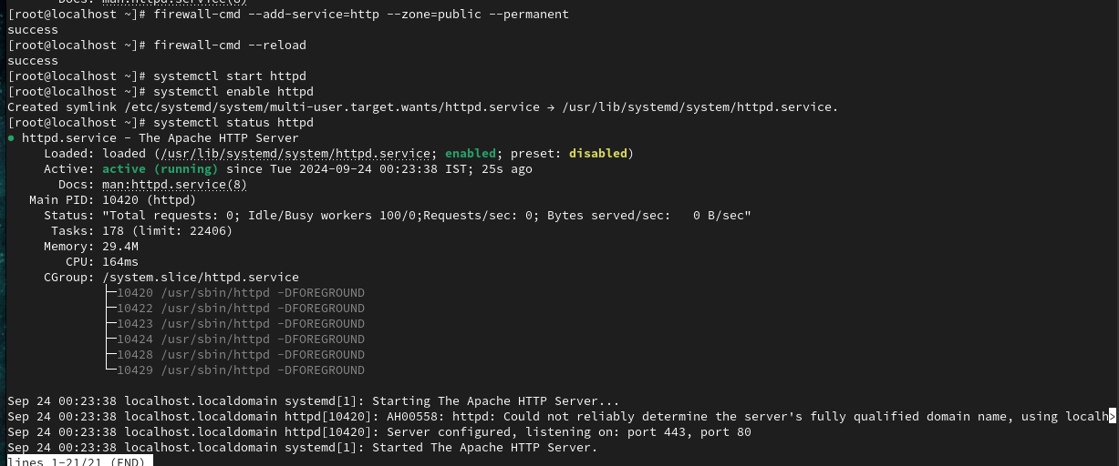

**Configure the IP Address:**

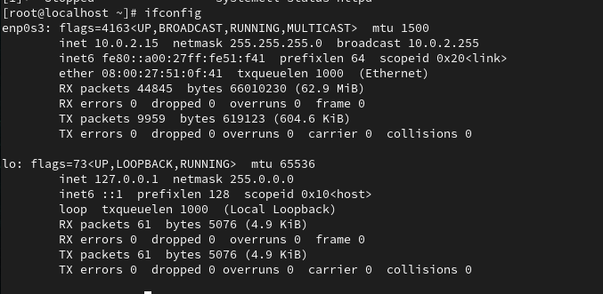

**To Check the test page ,open a web browser and enter the server's IP Address:**

